# ALL ABOUT WEB3 GAMING

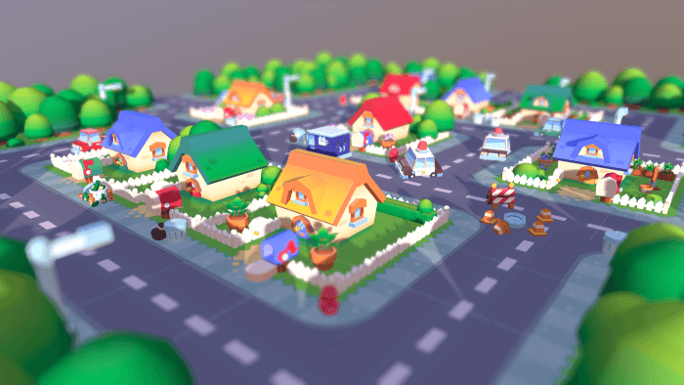

# ALL ABOUT WEB3 GAMING

[Get a free consultation](https://www.leewayhertz.com/contact-us/?web3gaming)



Web3 has revolutionized various industries, including gaming. With a major shift from traditional gaming platforms, Web3-based games allow the players to engage with the games in innovative and decentralized ways. People can play to earn via cryptocurrencies and NFTs. This democratizes all aspects of gaming and puts the main power in the hands of the player instead of confining it to one central authority within a game.

Although in traditional gaming, in-game content or digital assets are purchasable with fiat currency or can be claimed as rewards, game operators still reserve the copyrights to the in-game content. In simple words, players do not own the in-game digital assets. Instead, in traditional gaming, players’ ownership is simply a license for engaging with the aspects of the game.

Further, centralized gaming servers store all game-related information on servers, which game administrators control and operate. Game developers do not have adequate resources or knowledge to monitor and allow a trade where players want to exchange their digital assets to earn a profit.

Because of the inefficiency of centralized servers and traditional gaming, gray markets have surfaced to provide scope for hackers and scammers. They exploit players and provide no benefit to developers and administrators. Administrators fail to safeguard gaming platforms and their players from shutdowns and cyberattacks. Because of the centralized server and its inefficiency in safeguarding itself against hacks, the digital assets are also at high risk of loss, fraud and theft.

To address the problems listed here, Web3 gaming offers innovative techniques such as gaming Decentralized Autonomous Organizations (DAOs) with decentralized gaming ecosystems, blockchain-based game asset ownership, play-to-earn, crypto-secured gaming wallets and metaverse gaming.

This article will unfold the aspects of Web3 gaming and its dynamic features.